Name: Date: short (oo) words

The short (oo) sound is usually represented by the letters oo. In a very few words, the letter u is used to represent the short (oo) sound, like in the words below. Because there are so few of these words, they are all naughty red words.

Remember: Say the word aloud, then say each letter aloud as you write it e.g. 'put, p ... u ... t'
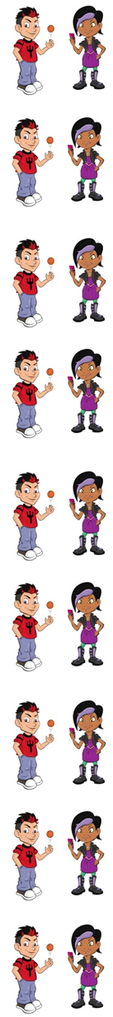
You really put your foot in it.

A bull is a male cow.

A sheep is full of wool!

You should never pull anyone's hair.

Neil will always push in front of Gary.

A bush is not as tall as a tree.

The word wolf is a naughty red word that belongs to Nina and Neil because the letter o is used to represent the short (oo) sound.
A wolf is a type of wild dog.

Now test yourself without looking at the words and check for yourself if you got them all right. Practice writing any words that you made mistakes on again.

© www.SaveTeachersSundays.com 2013
Name: Date: short (oo) words

The short (oo) sound is usually represented by the letters oo. In a very few words, the letter u is used to represent the short (oo) sound, like in the words below. Because there are so few of these words, they are all naughty red words.

Remember: Say the word aloud, then say each letter aloud as you write it e.g. 'put, p ... u ... t'

Try to spell each word without looking at it.

You really your foot in it.

A is a male cow.

A sheep is of wool!

You should never anyone's hair.

Neil will always in front of Gary.

A is not as tall as a tree.

A is a type of wild dog.

Now check for yourself if you got them all right. Practice writing any words that you made mistakes on again.

© www.SaveTeachersSundays.com 2013

